Exploratory Data Analysis (EDA) & Data Visualization – Project Report

Author:Balaji K

Project Type:Individual Project

Git Repo Link:

https://github.com/balajikrishnapillai

/CodeAlpha_EDA_Visualization

EXECUTIVE SUMMARY
The Exploratory Data Analysis (EDA) and Data Visualization project is developed using Python to analyze and visualize book data extracted from a web scraping process. The project focuses on understanding price distribution, rating patterns, and relationships between price and rating.
Using Pandas for data manipulation, Matplotlib and Seaborn for visualization, meaningful insights were generated from the dataset. The project demonstrates how raw CSV data can be cleaned, transformed, and analyzed to extract useful business insights.
This project highlights the importance of EDA as a critical step before applying machine learning or advanced analytics.
PROJECT OVERVIEW
Objective
To perform exploratory data analysis on a books dataset and generate visual insights using Python visualization libraries.

Scope
• Load structured CSV dataset
• Clean and transform price column
• Convert rating categories into numeric values
• Perform statistical analysis
• Generate visualizations (Histogram, Count Plot, Box Plot)
• Interpret patterns and relationships
DATASET DESCRIPTION
File Name: books_data.csv
Columns:
• Title
• Price
• Rating
• Availability
Total Records: 20 books
Data Type: Mixed (String & Numeric after cleaning)
DATA PREPROCESSING
Price Cleaning
The special currency symbol was removed and converted to float datatype for numerical analysis.
df["Price"] = df["Price"].str.replace("Â£", "", regex=False).astype(float)
Rating Conversion
Text ratings were mapped to numeric values:

Text Rating | Numeric Value
One | 1
Two | 2
Three | 3
Four | 4
Five | 5
This allows statistical calculations and plotting.
ANALYSIS PERFORMED
Statistical Summary
• Used df.info() to check structure
• Used df.describe() for statistical metrics
• Calculated Average Price
• Counted frequency of Ratings
Visualizations Generated
Price Distribution (Histogram)
- Displays distribution of book prices
- Helps identify price concentration range
Rating Count (Seaborn Countplot)
- Shows frequency of each rating category
- Helps understand customer preference trend

Price vs Rating (Boxplot)
- Shows relationship between price and rating
- Helps detect price variation across ratings
TECHNICAL IMPLEMENTATION
Technology Stack
• Programming Language: Python
• Data Manipulation: Pandas
• Visualization: Matplotlib & Seaborn
• Development Tool: VS Code / Jupyter Notebook
KEY INSIGHTS
• Most books fall within a moderate price range
• Certain ratings appear more frequently
• Price distribution varies across rating levels
• No missing values detected
• Clean structured dataset ready for advanced analytics
PERFORMANCE
• Efficient data preprocessing
• Clear statistical summary
• Meaningful graphical representation
• Smooth execution without errors

SOURCE CODE IMPLEMENTATION (Screenshot)
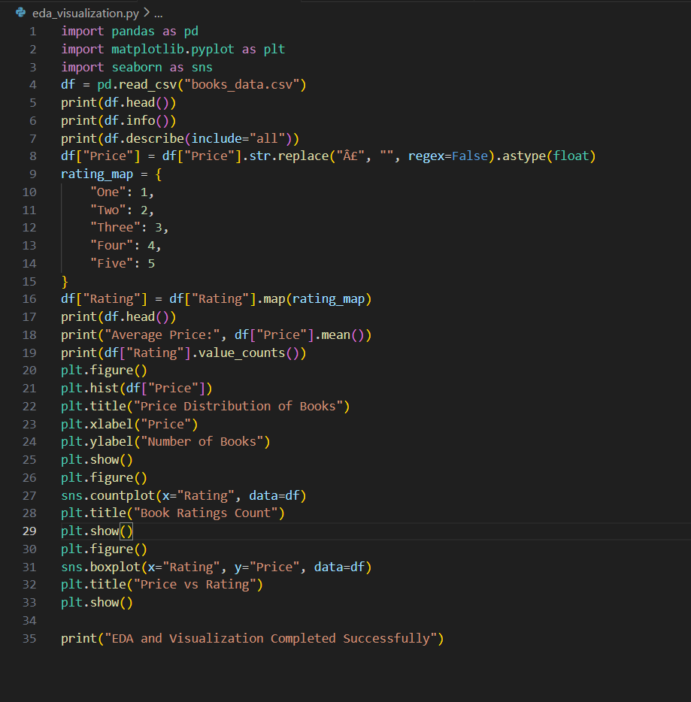

Extracted Job Result:

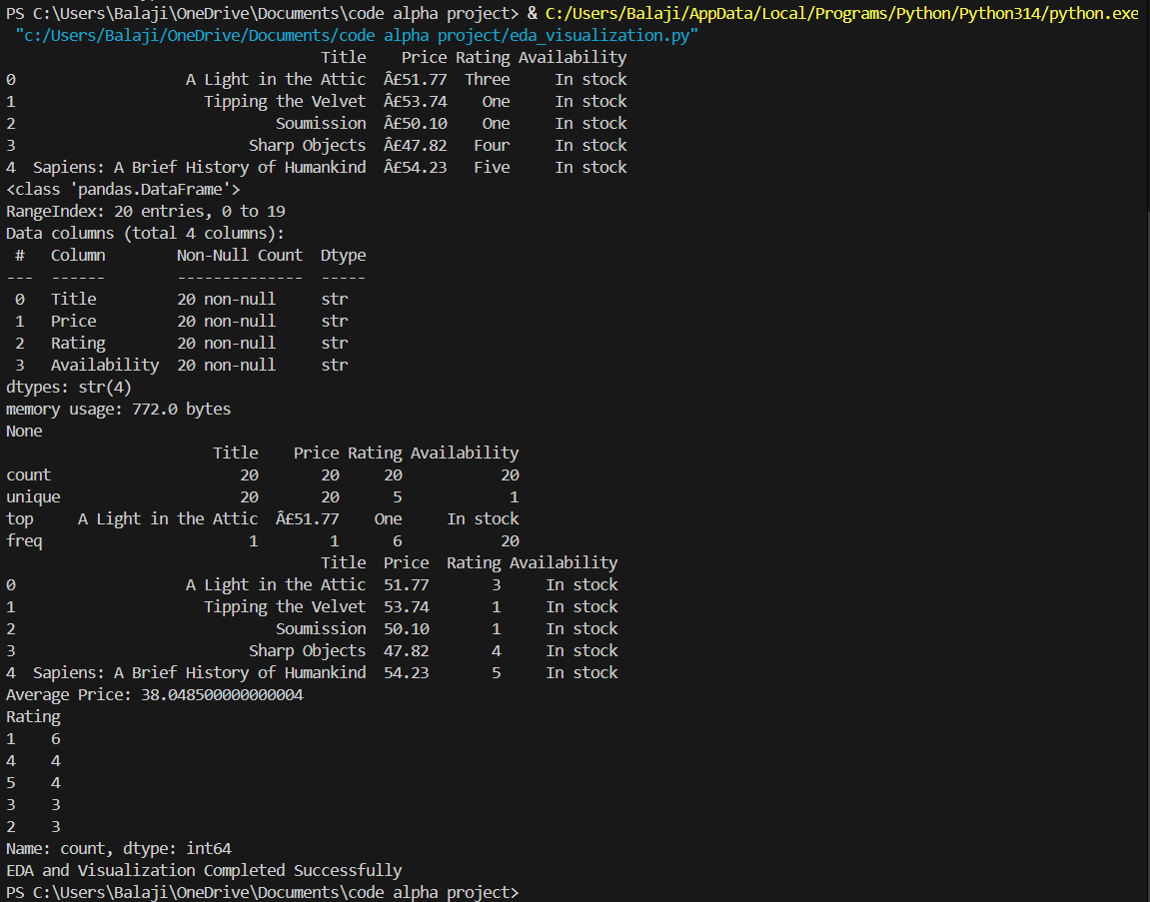

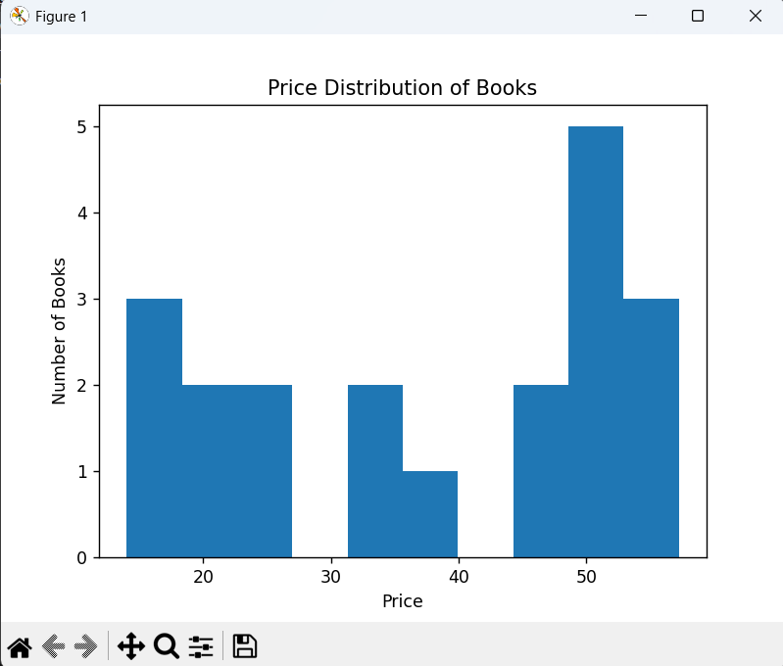

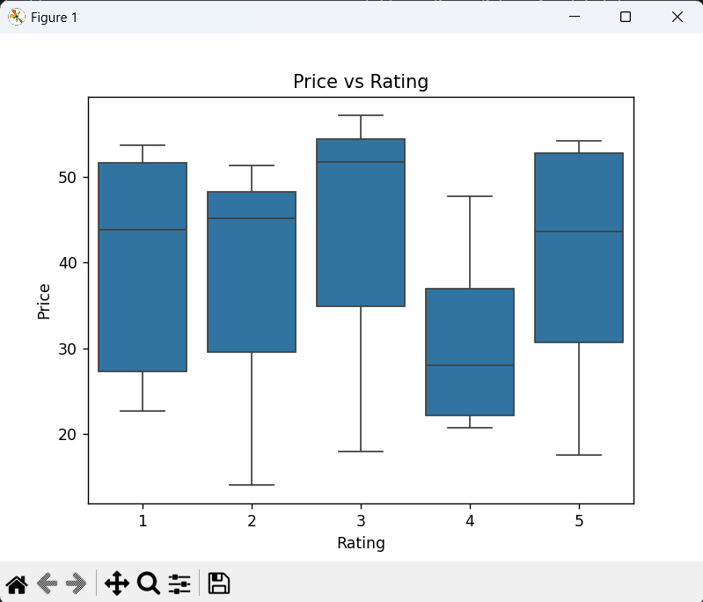

CONSTRAINTS
• Small dataset size (20 records)
• Limited to one webpage data
• No advanced statistical modeling
• Static dataset (not real-time)

PROJECT IMPACT
Immediate Benefits
• Strong understanding of EDA workflow
• Practical experience with data cleaning
• Visualization skill development
• Improved analytical thinking
Future Improvements
• Add correlation heatmap
• Perform price trend analysis
• Include multiple pages data
• Apply machine learning models
• Create interactive dashboards (Plotly / Power BI)

CONCLUSION
The EDA and Data Visualization project successfully demonstrates how structured data can be cleaned, analyzed, and visualized to extract meaningful insights. Using Pandas for preprocessing and Matplotlib/Seaborn for visualization, the project provides a strong foundation in data analytics and prepares the dataset for advanced analysis or machine learning applications.

